University Research Ethics Committee
Front cover sheet for applications
Applicant’s name: A.A.D Ushan Sankalpa Adhikari
Project Title: Learning preference-based Resource Recommendation System
Application Reference ___ - ___ - ___ (for office use only)
Please complete the checklist below before submitting your ethics application
Enclosed: | YES | NO | N/A
Application Form Part A attached.

Application Form Part B attached (if applicable).

Any external ethical approval (copy of application and approval letter) attached.

Draft Participant Information Sheet attached (see available exemplars).

Draft Informed Consent Form attached (see available exemplars).

Draft Indicative Questions, e.g. questionnaire(s), proposed interview questions or questioning areas, etc. attached.

Appropriate risk assessments have been completed, e.g. Control of Substances Hazardous to Health (COSHH), Radiation, etc. (if applicable) – Contact the University’s Safety, Health and Wellbeing Team for advice on this and other aspects of health and safety.

Fieldwork Risk Assessment attached (if applicable).
(UCEA Guidance on Health and Safety in Fieldwork Including offsite visits and travel in the UK and overseas) – Contact the University’s Safety, Health and Wellbeing Team for advice on this and other aspects of health and safety.

Travel Insurance Request clearance notification attached (if applicable).
Contact - Andrew Clarke (a.clarke03@westminster.ac.uk) or Alison Sylvestre (a.sylvestre@westminster.ac.uk) in Procurement if advice is required – This is essential if there is any Foreign and Commonwealth Office or RED24 advice against travel.

Confirmation of Insurance coverage for research undertaken off campus.

Security-sensitive research assessment completed (if applicable) and uploaded (see UniversitiesUK Guidance and, if applicable, complete the Annex to Part B and upload).

Other (please specify, e.g. letters from collaborators, etc.):

__________________________________________________________________

Applicant’s signature: 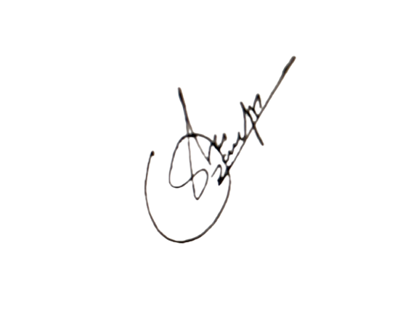Date: ________09/11/2022____________
Supervisor’s or Faculty
Research Director’s signature: ___________________________ Date: ____________________

PLEASE RETURN THIS COVER SHEET ALONG WITH THE REQUIRED DOCUMENTS BY EMAIL ATTACHMENT TO:
SECRETARY, FACULTY RESEARCH ETHICS COMMITTEE (or Contact your Supervisor).

